

CAPSTONE PROJECT REPORT
Report 2 – Project Management Plan

Table of Contents
I. Record of Changes 3
II. Project Management Plan 4
1. Overview 4
1.1 Scope & Estimation 4
1.2 Project Objectives 7
1.3 Project Risks 7
2. Management Approach 9
2.1 Project Processes 9
2.2 Quality Management 9
2.3 Project Training Plan 11
3. Responsibility Assignments 11
4. Project Communications 13
5. Configuration Management 13
5.1 Document Management 13
5.2 Source Code Management 14
5.3 Tools & Infrastructures 14

I. Record of Changes
Date | A*  M, D | In charge | Change Description
23/9/2025 | A | DuongNT | Added Project Management Plan
24/09/2025 | M | DuongNT | Modified Project Management Plan
24/09/2025 | M | HuyNX | Modified Project Management Plan
30/09/2025 | M | HuyNX | Modified Overview
30/09/2025 | M | DuongNT | Modified Overview
03/10/2025 | M | HuyNX | Modified Project Management Plan
03/10/2025 | M | DatVV | Modified Project Management Plan
*A - Added M - Modified D - Deleted

II. Project Management Plan

1. Overview

1.1 Scope & Estimation
# | Work Package | Est.Effort  (pds) | Deadline
1 | Stage 1: Project Management (weeks 1) | 20
1.1 | Initial Planning | 13 | Week1
1.1.1 | Meeting with mentor | 2
1.1.2 | Meeting with team | 2
1.1.3 | Define project goals and objectives | 2
1.1.4 | Collect and analyze data from survey | 2
1.1.5 | Define project scope and limit | 2
1.1.6 | Create Report 1: Project Introduction | 3
1.2 | Planning | 7 | Week1
1.2.1 | Iteration planning | 2
1.2.2 | Develop a project timeline | 2
1.2.3 | Create Report 2: Project Management Plan | 3
2. | Stage 2: Software Development | 304 | Week2
2.1 | Integration 1 (weeks 2-4) | 80
2.1.1 | Requirements | 9 | Week4
2.1.1.1 | Analyze context diagram and use case diagram | 4
2.1.1.2 | Analyze requirements and write software specification documents for modules Integration 1: Authentication, Product & Inventory Management | 5
2.1.2 | Analysis and design | 12 | Week4
2.1.2.1 | Build base project code structure | 4
2.1.2.2 | Analyze system architecture/package diagram and design database | 4
2.1.2.3 | Write Software Design Document for Integration 1 | 4
2.1.3 | Implementation Iteration 1 | 38 | Week4
2.1.3.1 | Code module 1: Authentication, Product | 18 | Week2
2.1.3.2 | Code module 2: Inventory management | 18 | Week4
2.1.3.3 | Fix bug | 2 | Week4
2.1.4 | Testing | 17
2.1.4.1 | Design unit/integration/system test cases | 5
2.1.4.2 | Execute test cases | 7
2.1.4.3 | Write Software Testing Document | 5
2.1.5 | Review & Retrospective | 4
2.2 | Integration 2 (weeks 5-7) | 86
2.2.1 | Requirements | 9 | Week7
2.2.1.1 | Update previous requirements | 3
2.2.1.2 | Analyze and document for Order & Payment | 6
2.2.2 | Analysis and Design | 9 | Week7
2.2.2.1 | Update design documents | 3
2.2.2.2 | Write design for Integration 2 | 6
2.2.3 | Implementation Iteration 2 | 44 | Week7
2.2.3.1 | Update previous modules if needed | 4
2.2.3.2 | Code module: Order | 18 | Week6
2.2.3.3 | Code module: Payment | 18 | Week7
2.2.3.4 | Fix bug | 4
2.2.4 | Testing | 20 | Week7
2.2.4.1 | Update test cases for prior integrations | 2
2.2.4.2 | Create & execute test cases for Integration 2 | 13
2.2.4.3 | Update testing document | 5
2.2.5 | Review & Retrospective | 4 | Week7
2.3 | Integration 3(weeks 8-10) | 74
2.3.1 | Requirements | 8 | Week10
2.3.2 | Analysis and Design | 8 | Week10
2.3.3 | Implementation Iteration 3 | 34 | Week10
2.3.3.1 | Update older modules | 4
2.3.3.2 | Code module: Customer Management | 10 | Week9
2.3.3.3 | Code module: Users Management | 14 | Week10
2.3.3.4 | Fix bug | 6 | Week10
2.3.4 | Testing | 20 | Week10
2.3.5 | Review & Retrospective | 4 | Week10
2.4 | Integration 4(weeks 11-13) | 64
2.4.1 | Requirements | 8 | Week13
2.4.1.1 | Update requirements and specification documents for previous integrations (1–3) | 3
2.4.1.2 | Analyze and document requirements for Integration 4: Analytics & Reporting | 5
2.4.2 | Analysis and Design | 8 | Week13
2.4.2.1 | Update design documents for previous integrations (1–3) | 3
2.4.2.2 | Write Software Design Document for Integration 4 | 5
2.4.3 | Implementation Iteration 4 | 24 | Week13
2.4.3.1 | Update existing modules if required | 3
2.4.3.2 | Code module: Analytics & Reporting | 17
2.4.3.3 | Fix bug | 4
2.4.4 | Testing | 24 | Week13
2.4.4.1 | Update and execute test cases for previous integrations | 9
2.4.4.2 | Create & execute test cases for Integration 4 | 15
2.4.5 | Review & Retrospective | 4 | Week13
3 | Stage 3: Closing (week 14) | 16
3.1 | Write Software User Guides | 4 | Week14
3.2 | Report 7: Final Project Report | 4 | Week14
3.3 | Presentation File | 8 | Week14
Total Estimated Effort (man-days) |  | 340

1.2 Project Objectives
# | Metric | Unit | Planned | Actual | Notes / References
1 | Effort Usage | Person-day | 490 | 490 | Total estimated effort from Scope and Estimation (490 man-days)
2 | Review Defects | No of defects | ≤10 | 4 | Target to keep defects found during reviews low, based on quality management goals.
3 | Unit Test Defects | No of defects | ≤20 | 6 | Estimated based on unit testing for Integration 1, 2, and 3,4 (complexity of modules).
4 | Integration Test Defects | No of defects | ≤15 | 1 | Estimated for integration testing across all integrations, assuming module interactions.
5 | System Test Defects | No of defects | ≤10 | 5 | System-level testing defects, targeting high system stability.
6 | Timeliness | % | ≥ 90% | 95% | Total on-time deliverables / Total project deliverables, aiming for 90% on-time delivery.
7 | Requirement Completeness | % | ≥ 75% | 95% | Failed if <=75%

1.3 Project Risks
# | Risk Description | Impact | Possibility | Response Plans
1 | The Project Team doesn’t meet the deadline | Medium | High | Supporting and intensifying the meeting if there is a problem causing the task to be delayed and work overtime to complete  tasks.
2 | Illness or absence of team members | High | Medium | Members have to notify the team about illness or absence periods and the plan of how to keep up with the work process.
3 | Team members  misunderstand  the requirements. | Low | Low | Business analysts are required to provide clear explanations to ensure that project members have a precise understanding of their assigned functions. In  instances where team members misunderstand and execute incorrect functions, testers log bugs on project management platforms. This helps assign tasks to business analysts to clarify requirements, allowing  developers to perform their  functions accurately.
4 | Working online full time. Not able to meet offline  regularly | Medium | Low | Meeting through Google Meets daily when needed.
5 | Change requirements | High | High | All members discuss the priority of the requests that the mentor wants to change and make changes according to the priority of the change request.

2. Management Approach

2.1 Project Processes
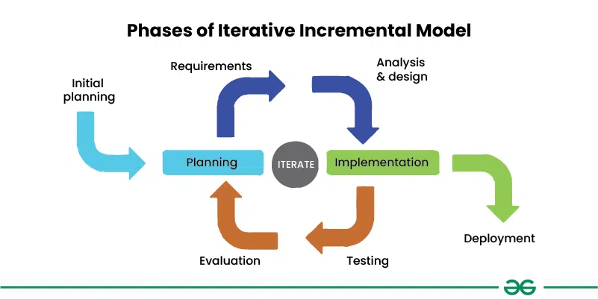
Figure 1.1: Phase of Iterative Incremental Model
The project applies an Incremental and Iterative Model to manage complex and frequently changing requirements based on feedback from supervisors and stakeholders. Iterative integration phases (Integration 1, 2, 3, 4) enable focused development, quality assurance, and adaptability. Each phase includes Requirements, Analysis/Design, Implementation, Testing, and Review/Retrospective stages, with reviews and retrospectives to verify deliverables, detect issues early, and plan adjustments, minimizing risks and ensuring user needs are met. This model promotes collaboration and continuous improvement throughout development.

2.2 Quality Management
Testing method | Target
Review | - Every member should give an honest review.  - If an error occurs, the finder should inform the responsible member so that they can plan and resolve the problem quickly.  - It is necessary to record and track the defects occurring in the software according to the priority and severity of the defect.  - The person responsible for a problem needs to plan and resolve the issue quickly.
Unit test | - In the unit testing phase, individual components and functions are tested separately and independently from all other parts of the system. The project employs automated tests that cover the logic of the controller and files.  - Each team member will perform the testing process concurrently with the coding process.  - Development team creates corresponding unit tests to ensure the matching with function code  - When unit function changes, unit tests need to be reviewed and run again.
Integration test | - Individual components on the backend and frontend will be integrated together before conducting integration testing.  - The team will design test cases that include test scenarios, test steps, expected outcomes, etc., to ensure no important cases are missed for the current integration.  - The interaction UI between components will be tested to ensure proper integration.
System test | - Depending on functional and non-functional requirements, the team will design test cases throughout the system testing process.  - System testing is conducted by testers. In this phase, the main focus is on the user interface to determine whether the system meets both functional and non-functional requirements.  - In case an issue is identified, it will be logged in Jira and assigned to the team members responsible for that feature.

2.3 Project Training Plan
Training Area | Participants | When, Duration
Spring Boot | Backend team | 08/09/2025
Reactjs | Frontend team | 08/09/2025
Figma | Frontend team | 08/09/2025
Git, Github | All members | 08/09/2025

3. Responsibility Assignments
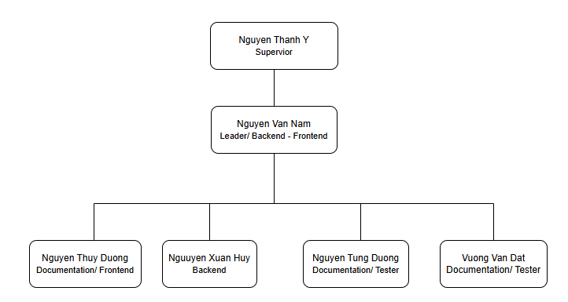
RACI Chart: R~Responsible, A~Accountable, C~Consulted, I~Informed
Work Package | NamNV | DuongNT | DuongNT | HuyNX | DatVV
Requirements Analysis | A | R | I | I | R
UI/UX Design | I | I | R | R | I
Frontend Development | I | I | R | R | I
Backend Development | A | R | I | I | I
Database Design | A | R | I | I | I
Testing & Quality Control | C | C | I | I | R
Documentation | I | I | I | I | R
Demo | R | R | R | R | R

4. Project Communications
Communication Item | Who/ Target | Purpose | When,  Frequency | Type, Tool,  Method(s)
Assign Tasks | All team member | The leader assigns tasks to other team members. | Once a week | Google Sheets
Weekly Meeting with Supervisor | All team member, Supervisor | Checking project progress. Plan upcoming tasks. Update requirements | Once a week | Offline
Weekly Meeting | Team  members | - Review tasks  - Check integration tasks progress.  - Support for hard  problems. | Every Sunday  from 10 - 16h | Offline
Daily Meeting | Team  members | - Report tasks  - Raise problems | Every day from  20h30 - 20h45 | Google Meet
Additional  Meeting | Team  members | Solving issues | Anytime when  team has  problems | Google Meet

5. Configuration Management

5.1 Document Management
- Management Tool: Store on Google Drive.
- Google Docs: Document Reports, User Guide.
- Google Sheets: QA Documentation
- Google Slides: Slide Presentation
After meeting with the Scrum master, Supervisor to discuss requirements, all documentation is created and transferred to management tools for storage and change tracking. Leaders initiate tasks in sheets and convey them to team members via Google Meet. Members subsequently edit the documents as needed, after which the Leader collects the documents for submission to the Supervisor.

5.2 Source Code Management
- Management Tools:
- GitHub: Manage coding resources.
- Google Sheet: Task management.
The Leader initiates tasks through google sheets and communicates them to team members via Google Meet. Members actively participate in the development process and complete their assigned tasks. All source code is then pushed to GitHub for version control. Subsequently, the team leader retrieves the code to deploy it in the development environment.

5.3 Tools & Infrastructures
Category | Tools / Infrastructure
Technology | SpringBoot (BackEnd), Reactjs (FrontEnd)
Database | SQL Server Management Studio
IDEs/Editors | Visual Studio Code, Intellij
Diagramming | DrawIO
Mockup | Figma
Documentation | Google Docs/Sheets/Slides
Version Control | GitHub (Source Codes), Google Drive (Documents)
Deployment server | Virtual Private Server

